

F29So group report

Take two

Retake

Stage 1 Report Group 11



Contents

Outline 2

Purpose 2

Scope 2

Overview 2

Requirements 3

Acronym meaning: 4

Functional Requirements 4

Non-Functional Requirements 6

UML Use Cases 8

Risk Analysis 13

Risk Identification 13

Risk Analysis 14

Risk Planning 15

Main Plan 17

Front end Plan 17

Back end Plan 18

Stage 1 20

Stage 2 21

Stage 3 24

Gantt Chart 25

Costing 26

Breakdown Chart 26

Cost Descriptions 27

Staffing costs 27

Equipment 27

Installation and Training 28

Maintenance 28

Cost Table 29

Costing References 29

Usability mock-ups 30

Test Plan 31

Test Scenarios 32

Testing protocol 33

Initial Questionnaire: 35

Questionnaire 36

Conclusion 49

# Outline

Purpose

This document describes the user requirements for the online collaborative platform as requested by Smart Information Flow Technologies (SIFT). With this platform, we want to target artists and content creators and create a platform where they may be able to connect, create and share content. In response to the “mash-up” culture, popularized by applications such as Tok-tok, Retake is our attempt to achieve this goal.

This document is directed at Dr. Rick Freedman and the Smart Information Flow Technologies (SIFT) team. This document is intended to be viewed by either:

1. Dr. Rick Freedman and any of their appointed associate: for the client to be able to discern what form the final product will take as well as what features it may potentially have.
2. Group 11 / Team Take Two: as a way for the developers to keep an accurate record of what solution the team will attempt to produce.

## Scope

There is one system – Retake

The System will take the form of a web-based application that will allow users to connect with one another. The website will allow for instant messaging amongst users and a feature to create group sessions where participating users will be allowed to join and be given the ability to modify the project alongside each other.

The Database(s) will store:

1. Basic user information, contact details, websites/links, friends/connections, posts, gallery/media, direct messages, and group information. These should all be encrypted to stop people from viewing data that they should not have access to.

The system will collect behavioral information about the user’s activity while using the system. This information will be used to construct the user’s feed with content that they are most likely to be interested in.

Overview

The sections below will provide a general outline of the main features that the System will offer. They will also contain some detailed, specific requirements of the System developed for the customer.

# Requirements

|  |  |  |  |  |
| --- | --- | --- | --- | --- |
| MoSCoW | No. | F/NF | Iteration | Requirement |
| Must | 1 | F | 1 | Multiple people must be able to work on a single project at the same time. |
| Must | 2 | F | 2 | Be able to have group managers to moderate specific groups. |
| Should | 3 | F | 2 | Be able to produce reports to managers about platform usage. |
| Could | 4 | F | 1 | Allow people to log into an account. |
| Could | 5 | F | 1 | Allow for the showing of pictures and projects to other users. |
| Could | 6 | F | 2 | Have a whiteboard for doodling. |
| Could | 7 | F | 4 | Have media-editing/ audio filters and editing tools. |
| Would like | 8 | F | 4 | Multiple environments to collaborate in. |
| Must | 1 | NF | 3 | Have user-created libraries, which can be shown off to other users. |
| Must | 2 | NF | 3 | Remain family-friendly / Have moderation of posts and text chats. |
| Must | 3 | NF | 1 | Respond to many users on the network at 1 time. |
| Should | 4 | NF | 3 | Allow both amateur and professional users. |
| Should | 5 | NF | 1 | Target all, students, artists, content creators, businesses, and influencers. |
| Should | 6 | NF | 2 | Have appropriate licenses and checks for creative commons, so people can’t use someone else’s art as their own. |
| Should | 7 | NF | 1 | Data must be kept secure, following GDPR requirements. |
| Should | 8 | NF | 4 | Work with all current browsers and mobiles/ tablets. |
| Would like | 9 | NF | 3 | To have suggested public libraries recommended to users based on what they like. |
| Would like | 10 | NF | 4 | To have “different styles” of the website such as “playfield” to add challenges to websites regularly and offer rewards to keep people interested. |
| Would like | 11 | NF | 4 | New and innovative features that might not be present on other content-sharing platforms. |
| Must | 12 | NF | 1 | The project will be web-based. |

## Acronym meaning:

|  |  |
| --- | --- |
| Acronym | Explanation |
| FR | Functional Requirement |
| NFR | Non-Functional Requirement |

## Functional Requirements

**FR-1**: Multiple people must be able to work on a single project at the same time

How important: Must have

When to implement: Iteration 1

The ability to have multiple logged-in users work on single or multiple projects at any moment in time.

**FR-2**: Be able to have group managers to moderate specific groups

How important: Must have

When to implement: Iteration 2

The group manager is either the user who creates the group or someone to who the original creator transfers the power to.

**FR-3**: Be able to produce reports to managers about platform usage

How important: Should have

When to implement: Iteration 2

Group managers need different privileges from regular users, they need to be able to print out statistics for the group and access the settings of the group.

**FR-4**: Allow people to log into an account

How important: Could have

When to implement: Iteration 1

Different account types are needed:

* Guest accounts: These don’t need to be logged in, they are assigned when entering the website if you are not logged in. You can look at images but cannot post or collaborate with other website users.
* User accounts: These need to be signed up and logged into, they allow you to post pictures, messages, and work on projects with other users.
* Manager accounts: These aren’t really a thing. They are just a subgroup of the user accounts and are only applicable when in a group, as many people as you want can be a manager in a group, they will all have the same privileges but normally it would only be a select few.
* Admin accounts: These are held by the company, they are used to moderate all groups and posts, they have the right to remove posted pictures and ban people’s accounts.

**FR-5**: Allow for the showing of pictures and projects to other users

How important: Could have

When to implement: Iteration 1

Users must log in so that they can post images, images will be screened by admins to make sure everything is kept family friendly.

**FR-6**: Have a whiteboard for doodling

How important: Could have

When to implement: Iteration 2

One of our collaborative systems is a whiteboard to allow multiple users to draw on a single page at the same time.

**FR-7**: Have media-editing/ audio filters and editing tools

How important: Could have

When to implement: Iteration 4

Another collaborative system is to be able to edit audio with multiple people doing different parts at the same time.

**FR-8**: Multiple environments to collaborate in

How important: Would like

When to implement: Iteration 4

It would be nice to have multiple environments for users to collaborate in, such as a whiteboard, video editing, and sound editing but this would not be compulsory and would only be added later in the project once the more important requirements are completed.

## Non-Functional Requirements

**NFR-1**: Have user-created libraries, which can be shown off to other users

How important: Must have

When to implement: Iteration 3

Users add multiple posted images into a single folder to share or just so they can easily find them again.

**NFR-2**: Remain family-friendly / Have moderation of posts and text chats

How important: Must have

When to implement: Iteration 3

Moderation of posts by admins, messages, and posts will be monitored so that there is no NSFW or illegal posts or chats.

**NFR-3**: Respond to many users on the network at 1 time

How important: Must have

When to implement: Iteration 1

The project being a web application means that multiple people must be able to be on the website at the same time. If multiple people cannot be on the page at the same time, the collaboration will not be possible.

**NFR-4**: Allow both amateur and professional users

How important: Should have

When to implement: Iteration 3

Having different settings for amateur and professional users will be an easy way to accommodate everyone into being able to work how they please.

**NFR-5**: Target all, students, artists, content creators, businesses, and influencers

How important: Should have

When to implement: Iteration 1

Having different aspects of the website, allowing people to have advertisements on their pages for other apps (so long as they follow the moderation guidelines) will be allowed, this means that businesses and influencers can easily use the website as a page for their business. And having different tags for each image will allow users to find related information quickly and easily.

**NFR-6**: Have appropriate licenses and checks for creative commons, so people can’t use someone else’s art as their own

How important: Should have

When to implement: Iteration 2

Moderation will allow us to check if the image being posted has been posted before, if it has the user can be issued a warning and the original artist/poster can be notified that someone was trying to use their art.

**NFR-7**: Data must be kept secure, following GDPR requirements

How important: Should have

When to implement: Iteration 1

Data should be kept secure and encrypted so that no one can easily gain access. When setting up an account they must agree to guidelines that state we are allowed access to personal information and that upon them leaving the website after a certain amount of time, their personal data will be deleted from our systems.

**NFR-8**: Work with all current browsers and mobiles/ tablets

How important: Should have

When to implement: Iteration 4

The website should be able to scale to different sizes and different browsers should all be able to work with the website.

**NFR-9**: To have suggested public libraries recommended to users based on what they like

How important: Would like

When to implement: Iteration 3

Keep track of what the user is interested in by what they post and what they like, then recommend related images and tags.

**NFR-10**: To have “different styles” of the website such as “playfield” to add challenges to websites regularly and offer rewards to keep people interested

How important: Would like

When to implement: Iteration 4

Add challenges to the website to earn rewards that can be used on the website to show that they have completed the challenge. Challenges can range from a coding challenge to an art challenge, maybe even have general knowledge quizzes which willing participants can enter and earn rewards.

**NFR-11**: New and innovative features that might not be present on other content sharing platforms

How important: Would like

When to implement: Iteration 4

The task is to implement a new feature that is not seen in another platform of this type.

**NFR-12**: Project will be web-based

How important: Must have

When to implement: Iteration 1

The project will be a website that should support multiple devices and browser types.

## UML Use Cases

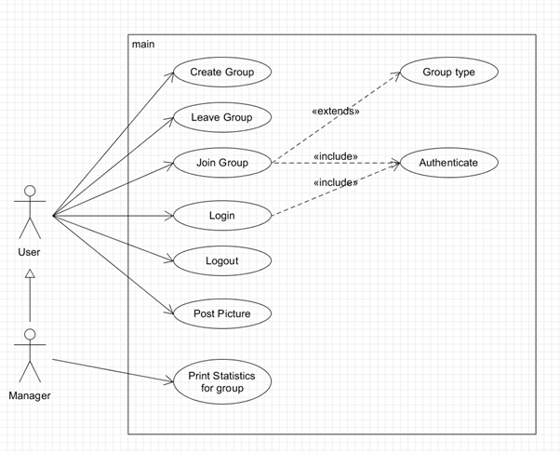

|  |
| --- |
| Use Case: Create Group |
| ID: 1 |
|  |
| Primary actor: User |
| Secondary actor(s): |
| Preconditions:   1. No group with the same name. |
| Postconditions:   1. Group with set name. |
| Main flow:   1. Enter Website. 2. Include (Login). 3. Choose unique Name. 4. Create group with Name and Type. 5. Original creator becomes Manager of group. |
| Alternative flows:   1. Name not unique 2. Ask user to enter unique Name |

|  |
| --- |
| Use Case: Leave Group |
| ID: 2 |
|  |
| Primary actor: User |
| Secondary actor(s): |
| Preconditions:   1. User in specified Group “G”. |
| Postconditions:   1. User not in group “G”. 2. User has no access to group “G”. |
| Main flow:   1. Enter Website. 2. Include (Login). 3. View group. 4. Leave group. |
| Alternative flows: |

|  |
| --- |
| Use Case: Join Group |
| ID: 3 |
|  |
| Primary actor: User |
| Secondary actor(s): |
| Preconditions:   1. Group “G” must exist. 2. User must not be in Group “G”. |
| Postconditions:   1. User in Group “G”. |
| Main flow:   1. Enter Website. 2. Include (Login). 3. Search for Group “G”. 4. Join Group “G”. |
| Alternative flows:   1. If Group “G” is private. 2. Creator must accept new User.      1. If Group “G” is private. 2. User joins instantly. |

|  |
| --- |
| Use Case: Login |
| ID: 4 |
|  |
| Primary actor: User |
| Secondary actor(s): |
| Preconditions:   1. User not logged into an account |
| Postconditions:   1. User logged into an account. |
| Main flow:   1. Include Authenticate. |
| Alternative flows:   1. Authentication fails. 2. User not logged in. |

|  |
| --- |
| Use Case: Logout |
| ID: 5 |
|  |
| Primary actor: User |
| Secondary actor(s): |
| Preconditions:   1. User logged into an account |
| Postconditions:   1. User not logged into an account |
| Main flow:   1. Enter Website. 2. User enters account. 3. User selects Logout. 4. User is logged out. |
| Alternative flows: |

|  |
| --- |
| Use Case: Post Picture |
| ID: 6 |
|  |
| Primary actor: User |
| Secondary actor(s): |
| Preconditions:   1. User logged into account. |
| Postconditions:   1. Picture posted on logged in account. |
| Main flow:   1. Enter website. 2. Include (Login). 3. Select Post Picture. 4. Select Picture. 5. Picture posted. |
| Alternative flows: |

|  |
| --- |
| Use Case: Print Statistics |
| ID: 7 |
|  |
| Primary actor: Manager |
| Secondary actor(s): |
| Preconditions:   1. Group “G” must exist. 2. User must be in Group “G”. |
| Postconditions:   1. Statistics printed to manager for Group “G”. |
| Main flow:   1. Enter website. 2. Include (Login). 3. Select print statistics for Group “G”. 4. Print statistics. |
| Alternative flows:   1. If user is not manager of group “G”. 2. Fail to print statistics. |

|  |
| --- |
| Use Case: Authenticate |
| ID: 8 |
|  |
| Primary actor: User |
| Secondary actor(s): |
| Preconditions:   1. Not logged in. |
| Postconditions:   1. Logged in. |
| Main flow:   1. Input username. 2. Input password. 3. Check if they match an existing account in system. |
| Alternative flows:   1. Username and password don’t match existing account. 2. Offer to create account with username and password. |

# Risk Analysis

## Risk Identification

|  |  |  |
| --- | --- | --- |
| **Risk** | **Likelihood** | **Category** |
| Team member departure | Medium | Project |
| Management issues | Low | Business |
| Requirements changing  (Scope Creep) | High | Project |
| Product not deployable on time | Low | Business, Project |
| Required Software Unavailable/Not Compatible | Medium | Technical |
| Cost of development higher than projected | Medium | Business |
| Poor User Engagement | Medium | Project |
| Code quality is subpar | High | Technical |
| Minor focus or output on detrimental sections of the project | Medium | Technical |
| Poor/Lack of communication between team members | High | Project |
| Loss of Project Work | Medium | Project, Product |
| Illnesses befalling team members | High | Project |
| Power outages at team members’ residence | Medium | Project |
| Too many feedback loops from users due to negative reception of UI/UX | High | Project |
| Segments of the product might be injectable/hackable | Low | Technical, Product |
| Final product might seem too similar to existing works such as Instagram | Medium | Business |

## Risk Analysis

|  |  |  |  |
| --- | --- | --- | --- |
| Risk | Likelihood | Category | Analysis |
| Team member departure | Medium | Project | A member of the team leaving before the project is completed. |
| Management issues | Low | Business | The manager of the project is either unreachable or manager is changed to another member of staff who needs to understand what is going on in the project. |
| Requirements changing  (Scope Creep) | High | Project | The client requests changes in the requirements/specifications often or requests a major change too late in the development cycle. |
| Required Software Unavailable/Not Compatible | Medium | Technical | With the recent release of Windows 11 and annual releases of MacOS, some dependencies might deprecate by the time the product is deployable. The app for phones form may not function on iPhone or work as intended with touch screens. The Web app might not work well with older browsers or have a buggy experience on Google Chrome. |
| Poor User Engagement | Medium | Project | The team may not have the chance to interact with potential users much during the end of the testing phase or even during all of development. Feedback loop with client occurs infrequently. The team cannot reach user. |
| Code quality is subpar | High | Technical | Code of the product might be rushed and unreadable and so cannot be worked on by multiple people. |
| Minor focus or output on detrimental sections of the project | Medium | Technical | Team members using more hours on tasks that are less necessary and less on the core features/tasks of the specification. |
| Poor/Lack of communication between team members | High | Project | The team not communicating effectively with each other therefore hindering project progression. |
| Illnesses befalling team members | High | Project | Team members may fall ill during the development cycle due to seasonal change and COVID-19, causing delays. |
| Power outages at team members’ residence | Medium | Project | As the project is worked on remotely, delays can be caused by residential issues such as failing network connection or power outages. |
| Too many feedback loops from users due to negative reception of UI/UX | High | Project | Usability mock-up may show that users do not enjoy working with the original UI, and changes will delay the project on a visual and coding fand marketing standpoint. |
| Segments of the product might be injectable/hackable | Medium | Technical, Product | The login page might be susceptible to being hacked, and, though the DB host itself secure, poor backend processing practices might have vulnerabilities to SQL injections and account data stealing. |

## Risk Planning

|  |  |  |
| --- | --- | --- |
| Risk | Analysis | Solution |
| Team member departure | A member of the team leaving before the project is completed. | As per specification guidelines, the rest of the team must pick up and complete the leaving members’ internally-assigned tasks, so the project is still complete by due date. |
| Management  issues | The manager of the project is either unreachable or manager is changed to another member of staff who needs to understand what is going on in the project. | Organize urgent meetings with the (new) manager to explain the project and our progress with it. Preferably, the team will attempt to get as much talk-time with the manager as possible to bring them up to speed. |
| Requirements changing  (Scope Creep) | The client requests changes in the requirements/specifications often or requests a major change too late in the development cycle. | Host a team meeting to discuss if the changes can be met or if any team member is available to address the changes. If so, assign the new task to the member and if not, attempt to contact the Client and try to reach a compromise on the new scope of the project. |
| Required Software Unavailable/Not Compatible | With the recent release of Windows 11 and annual releases of MacOS, some dependencies might deprecate by the time the product is deployable. The app for phones form may not function on iPhone or work as intended with touch screens. The Web app might not work well with older browsers or have a buggy experience on Google Chrome. | Detail the outdated/deprecated libraries in the README or user guide. During the development cycle, keep all dependencies updated and constantly test for changes in features and functions of the product. A good starting point would be to constantly test the web-app on all platforms whether it is Chrome, Firefox, Edge, Safari, Android, and iPhone. |
| Poor User Engagement | The team may not have the chance to interact with potential users much during the end of the testing phase or even during all of development. Feedback loop with client occurs infrequently. The team cannot reach user. | Request meeting with the client when possible, if need be. Otherwise, attempt to bring on more potential users to test the product and those that will provide feedback with every iteration of the product. |
| Code quality is subpar | Code of the product might be rushed and unreadable and so cannot be worked on by multiple people. | Cross-check the code of a team member with the rest of the team and attempt to get as much constructive feedback as possible (between each scrum split). |
| Minor focus or output on detrimental  sections of the project | Team members using more hours on tasks that are less necessary and less on the core features/tasks of the specification. | Hold team meetings weekly to review the progress each team member has made on their assigned task and review how close to complete the project is. |
| Poor/Lack of communication between team members | The team not communicating effectively with each other therefore hindering project progression. | Have the team leader attempt to contact the team member in question if there is one. If the problem lies within the whole group, the team must hold meetings and note non-attendance. |
| Illnesses befalling team members | Team members may fall ill during the development cycle due to seasonal change and COVID-19, causing delays. | All parts of development have been assigned in pairs so if a team member falls ill, their partner will attempt to further progress while the member is unavailable. |
| Power outages at team members’ residence | As the project is worked on remotely, delays can be caused by residential issues such as failing network connection or power outages. | This risk usually does not last too long but in cases that it does, the member’s partner will pick up on their tasks when possible. |
| Too many  feedback loops  from users due  to negative reception of  UI/UX | Usability mock-up may show that users do not enjoy working with the original UI, and changes will delay the project on a visual and coding fand marketing standpoint. | Attempt to receive and understand a clear visual idea of a UI/UX the client/user would prefer, either through a questionnaire or direct contact and then work on implementing such, if possible. This way the feedback loops are kept to a minimum. |
| Segments of the product might be injectable or hackable | The login page or posting page might be susceptible to being hacked, and, though the DB host itself secure, poor backend processing practices might have vulnerabilities to SQL injections and account data stealing. | During testing, ask the tester to Whitehat hack the website as much as possible. If not possible, ask knowledgeable testers or users to attempt the same. Attempt SQL injections periodically during development of the backend to ensure the product is secure. |

# Main Plan

## Front end Plan

Retake is a collaborative social media platform that also allows users to work on projects together. This platform is introduced by a login page, once the correct credentials are entered the user is swiftly transferred to the main page. The main page consists different options and once selected an overlayed window will appear. These windows include:

* Main page (scrolling through other followed pages)
* Login page (logging in)
* Profile page (your personal page)
* Notification page (invites to groups, requests to follow)
* Discovery page (finding new images)
* Posting page (selecting an image to post)
* Messages (group and personal messages)
* Collab page (list of collaboration groups)
* Whiteboard page (the main program for collaborating)

The frontend will be implemented using different languages consisting of HTML, CSS, and some JavaScript. The front end will show all the visible aspects for the user to interact with, these interactions include logging in on the login page. Once a user creates an account this data will be sent to the backend storing the information and therefore access will be given to the website.

Plenty of tools are available on the collaborative page for the user to make edits therefore JavaScript will be required on both the server-side and client-side to allow the users to interact with the page fluently.

Another page that requires JavaScript is the discovery page, the user should be able to effortlessly like and dislike the posts and move on to the next. Liking and disliking will affect the algorithm which will adjust the current home page feed to be more unique to the user. This allows the backend to calculate what to show the user on the front end of the website.

CSS will also be used to add style to each web page to keep a consistent design and to help readability.

## Back end Plan

-Login page (logging in and signing up)

When a new user is created, their email and UNIQUE username are INSERT queried into a table of accounts in the database – the username will be the PRIMARY KEY here. The password is converted to MD5 hash (using an algorithm coded originally and NOT a dependency/plugin) and the resulting encrypted string is stored under the password field. When the user logs in, the backend will perform a Quick Sort over the list of usernames in the table and then use Binary Search to find the input username. If a match is found, it converts the input password to MD5 and checks to see if the resulting string matches that of the corresponding username.

-Profile page (your personal page)

When a new user is created, they are asked to (optionally) add descriptions/bios to their profile. A separate table with the username calling a References tag (this will be a FOREIGN KEY) to username input will be the identifier and each user has a description field to them. When the desc/bio is edited, the old one in place is SELECTed, DELETEd and the new one is INSERTed.

-Notification page (invites to groups, requests to follow)

There will be a separate table for invites and requests (using usernames as foreign key identifier/fetcher tag and primary key usernames for processing purposes) this will be reflected in the front end. At the moment, the procedure is to SELECT and COUNT and reflect that in the frontend. This is not auto refreshed.

-Discovery page (finding new images)

At random, public profiles will be put on display on the discovery page. This can be debated to be a poor design choice as usually a Discover page must have trending or popular profiles with lots of followers or quickly growing follower numbers but at the moment, we do not want to preplan a time budget specifically for the implementation of a decent trending detection algorithm. A hacky way of displaying a Popular page would be to select the profiles with the highest follower counts but this would lead to a static/stagnant Discover page. Towards the end of the development cycle, we will consider our tasks for our last two scrums and overall project completion and then reassess on whether to implement a trending algorithm for the Discover page.

-Posting page (selecting an image to post)

When an image is entered and uploaded, it will be processed by the backend such that it is inserted into a HashMap of pictures and then sent to the database and stored in the HashMap for the account that posted it. Each account has its own space in the database which is used to store all the images of the account, to show this to other users the server pulls from the database and stores the image locally and then displays it to the user which stores it on the client side. This way, each account has their own HashMap of pictures in the DB. The HashMap and the username (as the identifier) will be in a table of its own.

-Storing current projects

The database will store the current projects in a list which will have the manager's name and the group identification number, the current in use projects will be stored on the server and will be sent to and from each client whenever they are updated.

-Messages (group and personal messages)

Instant messaging and chat will be hosted on the Database too and as messages are sent on the front end, the backend will push to the DB, and then pull it from the recipients’ side.

|  |  |  |  |  |
| --- | --- | --- | --- | --- |
| **Task Name** | **Duration (Days)** | **Start Date** | **End Date** | **Who** |
| **Stage 1** | 40 | 16/10/2021 | 25/11/2021 |  |
| **Outline** | 3 | 20/10/2021 | 23/10/2021 | JB |
| Purpose | 2 | 20/10/2021 | 22/10/2021 | JB |
| Scope | 2 | 20/10/2021 | 22/10/2021 | JB |
| Overview | 2 | 21/10/2021 | 23/10/2021 | JB |
| **Requirements** | 8 | 23/10/2021 | 31/10/2021 | David |
| Identify Requirements | 2 | 23/10/2021 | 25/10/2021 | David |
| Categorize Requirements | 2 | 25/10/2021 | 27/10/2021 | David |
| Create UML Diagram | 1 | 27/10/2021 | 28/10/2021 | David |
| Create Use cases for diagram | 2 | 28/10/2021 | 30/10/2021 | David |
| Change requirements if necessary | 1 | 30/10/2021 | 31/10/2021 | David |
| **Risk Analysis** | 11 | 28/10/2021 | 08/11/2021 | Harsh |
| Identification | 4 | 28/10/2021 | 01/11/2021 | Harsh |
| Analysis | 4 | 01/11/2021 | 05/11/2021 | Harsh |
| Planning | 3 | 05/11/2021 | 08/11/2021 | Harsh |
| Monitoring | 132 | 08/11/2021 | 20/03/2022 | Harsh |
| **Project Planning** | 5 | 09/11/2021 | 14/11/2021 | David |
| Frontend plan | 2 | 09/11/2021 | 11/11/2021 | JB, Kearann, Abdul |
| Backend plan | 2 | 11/11/2021 | 13/11/2021 | David, Harsh |
| Create Gantt chart of workload | 2 | 12/11/2021 | 14/11/2021 | David, Harsh |
| **Costing** | 2 | 13/11/2021 | 15/11/2021 | Kearann |
| Create Costing projection | 2 | 13/11/2021 | 15/11/2021 | Kearann |
| **Usability Mock-ups** | 9 | 15/11/2021 | 24/11/2021 | Abdul, JB, Yufan, David |
| Introduction | 1 | 15/11/2021 | 16/11/2021 | Abdul, JB |
| Plan | 1 | 16/11/2021 | 17/11/2021 | Abdul, JB |
| Mock-ups | 3 | 17/11/2021 | 20/11/2021 | Abdul, JB, Yufan |
| Create Questionnaire | 4 | 18/11/2021 | 22/11/2021 | Abdul, JB |
| Findings | 2 | 22/11/2021 | 24/11/2021 | Abdul, Kearann, David |
| Conclusion | 1 | 23/11/2021 | 24/11/2021 | Abdul, Kearann, David |
| Changes | 1 | 23/11/2021 | 24/11/2021 | Abdul, Kearann, David |

## Stage 1

## Stage 2

|  |  |  |  |  |
| --- | --- | --- | --- | --- |
| **Task Name** | **Duration (Days)** | **Start Date** | **End Date** | **Who** |
| **Stage 2** | 69 | 26/11/2021 | 03/02/2022 |  |
| Website  Implementation | 59 | 26/11/2021 | 24/01/2022 | Everyone |
| **Sprint 1** | 14 | 26/11/2021 | 10/12/2021 |  |
| FR-1 | 2 | 26/11/2021 | 28/11/2021 |  |
| Coding | 1 | 26/11/2021 | 27/11/2021 | David, Harsh, Abdul, JB, Kearann |
| Testing | 1 | 27/11/2021 | 28/11/2021 | Kearann, JB, Yufan, Joe |
| Documentation | 1 | 27/11/2021 | 28/11/2021 | David, Kearann, JB |
| NFR-3 | 2 | 28/11/2021 | 30/11/2021 |  |
| Coding | 1 | 28/11/2021 | 29/11/2021 | David, Harsh, Abdul, JB, Kearann |
| Testing | 1 | 29/11/2021 | 30/11/2021 | Kearann, JB, Yufan, Joe |
| Documentation | 1 | 29/11/2021 | 30/11/2021 | David, Kearann, JB |
| FR-4 | 2 | 30/11/2021 | 02/12/2021 |  |
| Coding | 1 | 30/11/2021 | 01/12/2021 | David, Harsh, Abdul, JB, Kearann |
| Testing | 1 | 01/12/2021 | 02/12/2021 | Kearann, JB, Yufan, Joe |
| Documentation | 1 | 01/12/2021 | 02/12/2021 | David, Kearann, JB |
| FR-5 | 2 | 02/12/2021 | 04/12/2021 |  |
| Coding | 1 | 02/12/2021 | 03/12/2021 | David, Harsh, Abdul, JB, Kearann |
| Testing | 1 | 03/12/2021 | 04/12/2021 | Kearann, JB, Yufan, Joe |
| Documentation | 1 | 03/12/2021 | 04/12/2021 | David, Kearann, JB |
| NFR-5 | 2 | 04/12/2021 | 06/12/2021 |  |
| Coding | 1 | 04/12/2021 | 05/12/2021 | David, Harsh, Abdul, JB, Kearann |
| Testing | 1 | 05/12/2021 | 06/12/2021 | Kearann, JB, Yufan, Joe |
| Documentation | 1 | 05/12/2021 | 06/12/2021 | David, Kearann, JB |
| NFR-7 | 2 | 06/12/2021 | 08/12/2021 |  |
| Coding | 1 | 06/12/2021 | 07/12/2021 | David, Harsh, Abdul, JB, Kearann |
| Testing | 1 | 07/12/2021 | 08/12/2021 | Kearann, JB, Yufan, Joe |
| Documentation | 1 | 07/12/2021 | 08/12/2021 | David, Kearann, JB |
| NFR-12 | 2 | 08/12/2021 | 10/12/2021 |  |
| Coding | 1 | 08/12/2021 | 09/12/2021 | David, Harsh, Abdul, JB, Kearann |
| Testing | 1 | 09/12/2021 | 10/12/2021 | Kearann, JB, Yufan, Joe |
| Documentation | 1 | 09/12/2021 | 10/12/2021 | David, Kearann, JB |
| Conclude Sprint | 1 | 09/12/2021 | 10/12/2021 | Everyone |
| **Sprint 2** | 14 | 11/12/2021 | 25/12/2021 |  |
| FR-2 | 4 | 11/12/2021 | 15/12/2021 |  |
| Coding | 2 | 11/12/2021 | 13/12/2021 | David, Harsh, Abdul, JB, Kearann |
| Testing | 1 | 13/12/2021 | 14/12/2021 | David, Harsh, Abdul, Joe |
| Documentation | 1 | 14/12/2021 | 15/12/2021 | Harsh, Abdul, Kearann |
| FR-3 | 4 | 15/12/2021 | 19/12/2021 |  |
| Coding | 2 | 15/12/2021 | 17/12/2021 | David, Harsh, Abdul, JB, Kearann |
| Testing | 1 | 17/12/2021 | 18/12/2021 | David, Harsh, Abdul, Joe |
| Documentation | 1 | 18/12/2021 | 19/12/2021 | Harsh, Abdul, Kearann |
| FR-6 | 3 | 19/12/2021 | 22/12/2021 |  |
| Coding | 1 | 19/12/2021 | 20/12/2021 | David, Harsh, Abdul, JB, Kearann |
| Testing | 1 | 20/12/2021 | 21/12/2021 | David, Harsh, Abdul, Joe |
| Documentation | 1 | 21/12/2021 | 22/12/2021 | Harsh, Abdul, Kearann |
| NFR-6 | 3 | 22/12/2021 | 25/12/2021 |  |
| Coding | 1 | 22/12/2021 | 23/12/2021 | David, Harsh, Abdul, JB, Kearann |
| Testing | 1 | 23/12/2021 | 24/12/2021 | David, Harsh, Abdul, Joe |
| Documentation | 1 | 24/12/2021 | 25/12/2021 | Harsh, Abdul, Kearann |
| Conclude Sprint | 1 | 24/12/2021 | 25/12/2021 | Everyone |
| **Sprint 3** | 14 | 26/12/2021 | 09/01/2022 |  |
| NFR-1 | 4 | 26/12/2021 | 30/12/2021 |  |
| Coding | 2 | 26/12/2021 | 28/12/2021 | David, Harsh, Abdul, JB, Kearann |
| Testing | 1 | 28/01/2021 | 29/01/2021 | David, Kearann, JB, Joe |
| Documentation | 1 | 29/12/2021 | 30/12/2021 | David, Harsh, JB |
| NFR-2 | 4 | 30/12/2021 | 03/01/2022 |  |
| Coding | 2 | 30/12/2021 | 01/01/2022 | David, Harsh, Abdul, JB, Kearann |
| Testing | 1 | 01/01/2022 | 02/01/2022 | David, Kearann, JB, Joe |
| Documentation | 1 | 02/01/2022 | 03/01/2022 | David, Harsh, JB |
| NFR-4 | 3 | 03/01/2022 | 06/01/2022 |  |
| Coding | 1 | 03/01/2022 | 04/01/2022 | David, Harsh, Abdul, JB, Kearann |
| Testing | 1 | 04/01/2022 | 05/01/2022 | David, Kearann, JB, Joe |
| Documentation | 1 | 05/01/2022 | 06/01/2022 | David, Harsh, JB |
| NFR-9 | 3 | 06/01/2022 | 09/01/2022 |  |
| Coding | 1 | 06/01/2022 | 07/01/2022 | David, Harsh, Abdul, JB, Kearann |
| Testing | 1 | 07/01/2022 | 08/01/2022 | David, Kearann, JB, Joe |
| Documentation | 1 | 08/01/2022 | 09/01/2022 | David, Harsh, JB |
| Conclude Sprint | 1 | 08/01/2022 | 09/01/2022 | Everyone |
| **Sprint 4** | 14 | 10/01/2022 | 24/01/2022 |  |
| FR-7 | 3 | 10/01/2022 | 13/01/2022 |  |
| Coding | 1 | 10/01/2022 | 11/01/2022 | David, Harsh, Abdul, JB, Kearann |
| Testing | 1 | 11/01/2022 | 12/01/2022 | Harsh, Abdul, Yufan, Joe |
| Documentation | 1 | 12/01/2022 | 13/01/2022 | Harsh, Yufan, Kearann |
| NFR-8 | 3 | 13/01/2022 | 16/01/2022 |  |
| Coding | 1 | 13/01/2022 | 14/01/2022 | David, Harsh, Abdul, JB, Kearann |
| Testing | 1 | 14/01/2022 | 15/01/2022 | Harsh, Abdul, Yufan, Joe |
| Documentation | 1 | 15/01/2022 | 16/01/2022 | Harsh, Yufan, Kearann |
| FR-8 | 3 | 16/01/2022 | 19/01/2022 |  |
| Coding | 1 | 16/01/2022 | 17/01/2022 | David, Harsh, Abdul, JB, Kearann |
| Testing | 1 | 17/01/2022 | 18/01/2022 | Harsh, Abdul, Yufan, Joe |
| Documentation | 1 | 18/01/2022 | 19/01/2022 | Harsh, Yufan, Kearann |
| NFR-10 | 3 | 19/01/2022 | 22/01/2022 |  |
| Coding | 1 | 19/01/2022 | 20/01/2022 | David, Harsh, Abdul, JB, Kearann |
| Testing | 1 | 20/01/2022 | 21/01/2022 | Harsh, Abdul, Yufan, Joe |
| Documentation | 1 | 21/01/2022 | 22/01/2022 | Harsh, Yufan, Kearann |
| NFR-11 | 2 | 22/01/2022 | 24/01/2022 |  |
| Coding | 1 | 22/01/2022 | 23/01/2022 | David, Harsh, Abdul, JB, Kearann |
| Testing | 1 | 23/01/2022 | 24/01/2022 | Harsh, Abdul, Yufan, Joe |
| Documentation | 1 | 23/01/2022 | 24/01/2022 | Harsh, Yufan, Kearann |
| Conclude Sprint | 1 | 23/01/2022 | 24/01/2022 | Everyone |
| **Changes** | 7 | 25/01/2022 | 01/02/2022 |  |
| Changes of coding | 6 | 25/01/2022 | 31/01/2022 | David, Harsh, Abdul, JB, Kearann |
| Report changes | 7 | 25/01/2022 | 01/02/2022 | Everyone |
| Demonstration to  manager | 1 | 02/02/2022 | 03/02/2022 | Everyone |

|  |  |  |  |  |
| --- | --- | --- | --- | --- |
| **Task Name** | **Duration (Days)** | **Start Date** | **End Date** | **Who** |
| **Stage 3** | 55 | 04/02/2022 | 31/03/2022 | Everyone |
| **Marketing** | 7 | 04/02/2022 | 11/02/2022 | N/A |
| **Final Design and Implementation** | 7 | 11/02/2022 | 18/02/2022 | David, Harsh, Abdul, JB, Kearann |
| **Usability Evaluation** | 7 | 18/02/2022 | 25/02/2022 | JB, Abdul |
| **Project Evaluation** | 7 | 25/02/2022 | 04/03/2022 | Everyone |
| **Professional Conduct** | 7 | 04/03/2022 | 11/03/2022 | Manager (Wei Pang) |
| **Final Demonstration** | 13 | 11/03/2022 | 24/03/2022 | Everyone |

## Stage 3

## Gantt Chart

# Costing

This section will detail the overall cost of the project and break it down into different sections where the spending occurs.

## Breakdown Chart

This chart details the breakdown of project costs into subsections which are then elaborated upon in the costing table section below.

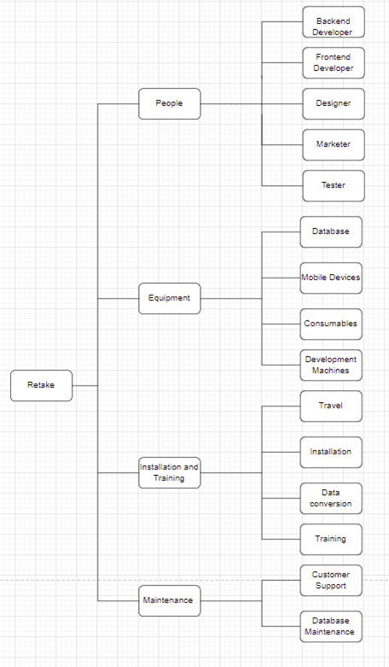

## Cost Descriptions

### Staffing costs

Backend developer

Backend developers will be responsible for building the database and integrating it into the system.

Frontend developer

Frontend developers will be responsible for creating and implementing the user facing code also maintaining the code.

Designer

Designers will be responsible for designing the products look and brand.

Marketer

Marketers will be responsible for marketing the finished product and helping to strengthen the brand.

Tester

Testers will be responsible for testing the product and preventing any bugs in the product.

### Equipment

Online database

This will be the rented database for the product, we have selected mongoDB for this application.

Consumables

This is any consumables that may be used while developing or marketing the product such as paper, ink, and USB’s.

Mobile devices

These will be rented mobile devices used to test and develop the product.

Development machines

These are rented computers that will be used to develop and test the product

### Installation and Training

Travel

These are the travel costs for the installation of the system and training of customer.

Installation pay

This is the extra wages for the staff installing the finished product.

Data conversion

This is a cost for if any data that needs to be converted for the new system.

Customer training

This is the cost for staff to train the customer on how to use product.

### Maintenance

Customer support

This is the cost of any support that the customer requires regarding the product.

Database management

This is the cost for any database maintenance that may be required.

## Cost Table

This table details the breakdown and allocation of costs for this project, including a 20% reserve for any unpredicted costs.

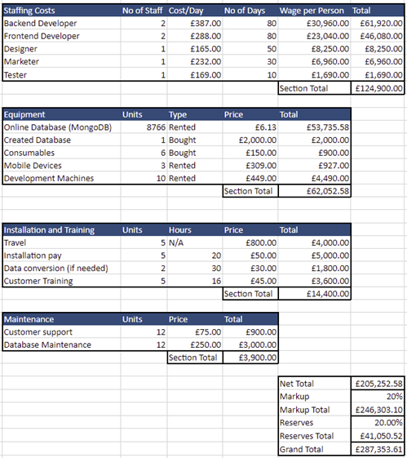

### Costing References

Development Machines: <https://www.amazon.co.uk/Dell-Inspiron-3891-Desktop-processor/dp/B099V7PZD5/ref=sr_1_8?keywords=desktop+computer&qid=1637667517&sr=8-8>

Mobile Devices: <https://amzn.to/3l0N1ym>

Average Backend developer salary: <https://uk.indeed.com/career/back-end-developer/salaries>

Average Frontend developer salary: <https://uk.indeed.com/career/front-end-developer/salaries/Edinburgh>

Average Web Designer: <https://www.payscale.com/research/UK/Job=Web_Designer/Salary>

Average marketing manager salary: <https://www.payscale.com/research/UK/Job=Marketing_Manager/Salary>

Average Software testing Salary: <https://www.payscale.com/research/UK/Job=Software_Tester/Salary>

# Usability mock-ups

Introduction

**Aims and Objectives**

This document contains a detailed plan that outlines what tests we will do to obtain results that will determine the usability of our systems prototype.

This report will present results that will hopefully show the relevance of the features we have added to our prototype. It can also indicate any issues with the design or if a change needed to be made because of being opted out for another which the users perform. If the test subjects do highlight a change, then they will be noted and presented to Stakeholders who will then decide if it should be implemented or not.

This document is directed at Dr. Rick Freedman and the Smart Information Flow Technologies (SIFT) team. This document is intended to be viewed by either:

1. Dr. Rick Freedman and any of their appointed associate:

for the client to see what the team produced based on the requirements. The client can also see potential users’ responses to the prototype made and what choices the developers made based on this information.

1. Team 11 / Team Take Two: as a way for the developers to match the requirements to feature and mock-up and introduce it to the potential users to test the usability.

**Scope**

**There is one System – the Retake System.**

The System will be a web application that will be available on every web browser. This will ensure that we can reach the largest audience possible. The System will also be supported on mobile devices and tables.

There will be unique profiles assigned to each user where they will have basic information display, a profile picture and a library of posts and galleries that other users can view. There will be group chats with a “Whiteboard“ in each group. The whiteboard will contain projects of multiple media types that the group members will have access to. The group members can all edit the same or separate times, and they can save the current or different versions of the project being worked on. The group admin can use his privileges over the normal members to reduce the power each member has.

The System will implement pop-ups, simple/eye-catching designs, and vibrant/dynamic pages to attract the desired audience we want to attract such as influencers and creatives.

Overview

## Test Plan

**Objective**

The test will help us assess our different users will think to react to our systems and designs. The user will observe a mock-up prototype then will describe what they think the purpose/goal of each page is and how they might go about achieving this goal.

Participants will be given a set of questions that will consist of various designs of the Retake platform, both application and website will be included. Before these sets of questions, an initial questionnaire will be asked to fill to collect information about the different users.

Participants are allowed to go into detail in some parts of the test. This allows us to see if there’s a connection between what the participant thinks the system will do vs what the system is designed to do. We are also able to extract any suggestions the participant may have about the design, layout, or features.

With the findings from this test, we hope:

* Participants can easily detect what each mock-up is intended to be doing.
* To obtain qualitive data about the user experience and usability of both platforms and quantitative data about the ease for users to complete the required tasks.
* To gather any issues or improvements participants may have highlighted.

**Participants**

The preferred candidates for the test are individuals over the age of 16 who are interested in content creation or the creative field, occupation in the art, creative and entertainment industries. It is not necessary that they possess these qualities as we need to observe how normal, “average” users

## Test Scenarios

|  |  |
| --- | --- |
| Question | Related Requirements |
| 1. Login Page | FR-4: Allow people to log into an account |
| 1. Joining a group | FR-1: Multiple people must be able to work on a single project at the same time.  FR-2: Be able to have group managers to moderate specific groups.  NFR-1: Have user-created libraries, which can be shown off to other users. |
| 1. Discovery Page | FR-5: Allow for the showing of pictures and projects to other users.  NFR-9: To have suggested public libraries recommended to users based on what they like. |
| 1. Whiteboard page (web) | FR-6: Have a whiteboard for doodling  FR-7: Have media-editing/audio editing tools.  FR-5: Allow for the showing of pictures and projects to other users.  NFR-12: Project will be web-based. |
| 1. Whiteboard page (mobile) | FR-6: Have a whiteboard for doodling  FR-7: Have media-editing/audio editing tools.  FR-5: Allow for the showing of pictures and projects work with all current browsers and mobiles/tablets. |

Test scenarios will utilize three values:

Complete/Confirmed – Subject showed a good understanding of the purpose and completed task.

Help needed – Subject required “hint” or assistance from investigator without revealing solution and was able to complete the task.

Unclear to the subject – Subject struggled to identify the purpose and/or could not complete the task even after being given hints.

This classing system can be used to track each participant’s performance in the different test scenarios. Any time a participant attains an “Unclear to the subject” or “Help needed”, this can indicate a flaw in the design.

An investigator will award “Complete/Confirmed” when they believe the subject has understood the task and completed it.

Quantitative data will be collected at the end of the main test. A Likert-style rating scale will be used to gather this data about how the participant responded to the webpage’s design, visual appeal, layout, usability. Then the participant is asked to provide any additional suggestions or comments they have about the website.

## Testing protocol

**Test supervisor**:_________________________________________________ **Date**:___________

**Participant** **ID.** __________ **Platform/Location**: __________

**Aim**

Participants will be interacting with a prototype of a system designed to connect multiple users on a platform and allow them to collaborate on a single project at the same time. The interface is still in the early stages of development so the inconsistent designs on some examples are intended to gauge how a user responds to different design types.

**Introduction**

You will be presented with mock-up prototypes of web pages and will be asked some questions about them. You will be asked to describe possible features that the webpage may possess, the different links and icons on the webpage may help you decide this. Then you will be asked to describe how you would perform some tasks and use the features previously described by yourself - if there are any.

The supervisor will monitor your responses to the questions and the actions you take. The supervisor will give you hints only when asked as they do not want to influence or interfere with your test.

The test is not graded, your responses and performances are personal to you and are only a reflection of the system itself.

If you wish to stop the test at any time, please make the test supervisor aware.

We ask that upon completing the test you complete a short questionnaire to collect further feedback about the website. The questionnaire will be anonymous.

Group 11/ Team Take Two

Heriot-Watt University

**Consent to Act as a Subject in an Experimental Study.**

**Principal Investigator:**

Abdullah Irfan Khan, David Capper, Harsh Mulani, Kearann Spence, Joseph Brown, Joe Chiverton, Yufan Liu

**Purpose:**  
The purpose of this experiment is to discern the usability of our web application designs. The website’s main function will be to enable artists, influencers, and content creators to collaborate with other users on the platform and share their work with other users. The website will include a discovery page where other users/groups’ works are shared and displayed to every user – each being unique to an individual user. We will also gauge how different users respond to the layout and the designs.

Your participation in this study is voluntary. If at any time you wished to stop participating in the study, you are free to do so. You are free to refuse to participate. Refusing to participate will not impact or alter your status with the university in any way. Any personal information collected will be kept confidential in password-protected computer directories.

If you have any questions, please contact one of the principal investigators.

**Voluntary consent:**

I have read the text above and understand my personal information is being kept confidential. I am aware I can stop participating at any time and my participation or decision to stop participating will have no effect on my status or relationship with the university. Any questions I had have been answered by my investigator. By signing below, I am declaring that I agree to participate in this study, and I agree for my results to be used for scientific and research purposes.

Participant’s signature: _______________________________ Date: __________

Investigator’s signature: ______________________________ Date: __________

## Initial Questionnaire:

1. What is your age?
2. What is your occupation?
3. How many years have you used computers?
4. Roughly, how long do you use your phone or computer in a day?
5. Have you used any collaborative study applications or websites?

## Questionnaire

1. Login Page

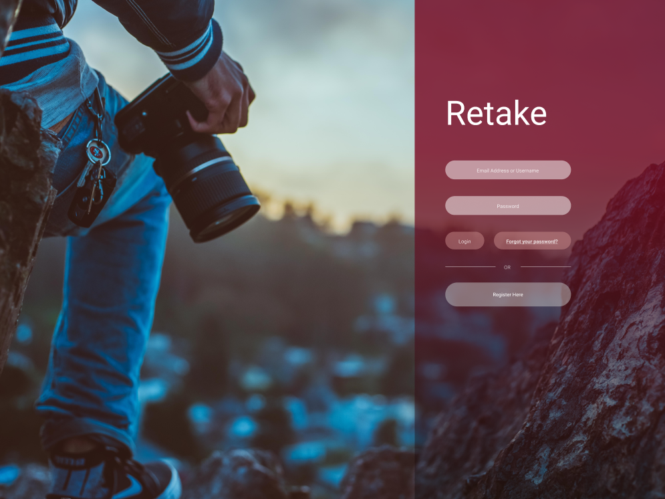

1. Are you able to describe the purpose of this page?

1. Who do you think would use this page? (Think about the purpose described above and any options that are available on the page).

1. Describe how you would go about logging into the website.

1. What would you do if you did not have an account? (What made you choose that option)
2. Joining a group

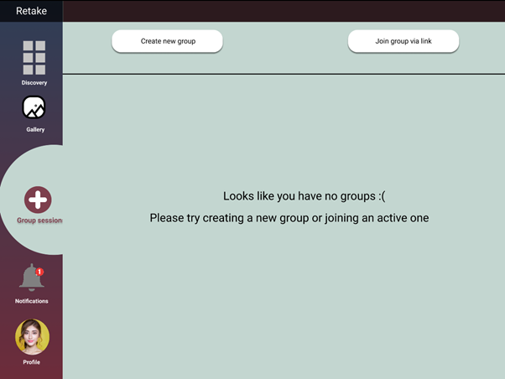

1. Can you describe the goal or purpose of the current tab?

1. Which icon would you click if you received a notification?

1. Do you like the layout of all the different link and icons? (Scale of 1-5)

1. Are you able to understand what each link would do?

1. Are there any options that you would expect to see that aren’t present?
2. Comparisons of discovery Pages (phone)

Page Comparisons

Figure 1. Figure 2.

1. Which discovery page do you prefer and why?

1. Do you prefer scrolling as shown on figure 1 or swiping to view new posts as shown on figure 2?

1. What do you think the X and “Heart” icon represent/what do they do?

Discovery page (Web)

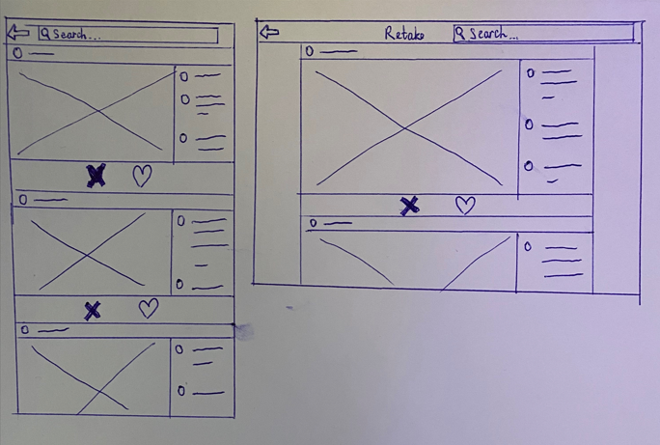

1. Are you able to describe the purpose of this page?

1. Do you prefer more information on the web version?

1. Do you wish you could navigate to different pages instead of having a return button?

1. By liking and disliking, this will alter the home page feed to your preference. Do you like this idea?

1. Whiteboard Page (Web)

1. Are the icons easy to understand?

1. From a scale of 1-5, how much do you like the design of this page?

1. Would you prefer the messages box to be smaller and instead have more tools to aid collaborating on the project?

1. Whiteboard page (phone)

1. Can you identify what this page is intended for?

1. Do you prefer clicking on more for extra tools or would you prefer each individual tool to be visible on screen?

Test Participants Demographic

|  |  |
| --- | --- |
| Age | |
| 18-21 | 6 |
| 22-24 | 3 |
| 25+ | 2 |

|  |  |
| --- | --- |
| Occupation | |
| Student | 7 |
| Quantity Surveyor | 1 |
| Barista | 1 |
| Entrepreneur | 1 |
| Customer Assistant | 1 |

|  |  |
| --- | --- |
| Computer literacy | |
| 5-10 years | 2 |
| 10+ | 9 |

|  |  |
| --- | --- |
| How long do you use your computer each day? | |
| 2-5 hours | 2 |
| 5-10 hours | 7 |
| 10+ hours | 2 |

|  |  |
| --- | --- |
| Have you ever used a collaborative/ study app before? | |
| Yes | 4 |
| No | 7 |

|  |
| --- |
| Collaborative apps used |
| Teams |
| Blackboard |

Test results

1. Login Page

**Functionality**-

It seems that most users were able to understand what the purpose of the page was. Majority of users answered using the key word “login in” which shows that the icons and appearance of the web page is appropriate in describing the main functionality.

One user commented saying “image cloud storage”. This keyword could possibly describe the purpose of the entire web application which may suggest the questions has been interpreted wrong.

**User Experience**-

When asked to describe how the user would go about performing the main task of the webpage, every participant completed the target task of this prototype. The participants gave detailed descriptions of the actions they would take.

**Audience**-

When asked about the functionality of the webpage, a few participants mentioned “taking photos” or photography-related keywords.

In the future the language of the question can be improved but, in this case, it turns out to be in our favor. As it means although, these users failed to answer the expected response, it does show that the user is able to find the whole application’s purpose from the design of the log-in page alone. The keywords relating to purpose show these users were able to identify the target audience.

**Target Task** -

The target task of the prototype was to attempt to log into the site. Every participant was able to accurately complete the task. Some even referred to the “sign up” feature which is a more appropriate action as these users do not have accounts set up already. This response shows the participant is personally relating to the task which could indicate they have a connection to the design.

This shows that the system appears easy to use as all participants attained Complete/Confirmed on this prototype’s target exercise.

**Changes/Improvements** -

No changes were specified by participants. The design and layout of the login page seems appropriate based on the results

1. Join group

**Functionality**-

Every tester was able to identify the functionality of the page, this information was gathered by the testers using keywords such as “join” and “create”. This suggests that the current page has a good informative design.

**User Experience**-

When asked to click on the notification icon, every tester was able to identify the bell at the top right of the page. This suggests that the icons used are user friendly and easy to understand.

The testers were also asked on their opinion of the layout, from the options below, the results showed that the majority liked the overall design of the page.

Strongly disagree – 0%

Disagree – 0%

Neutral – 9.1%

Agree - 54.4%

Strongly agree - 36.4%

**Target Task** -

The target task of the prototype was to understand how to create and join groups, ever participant was able to understand this as they were able to describe the functionality of everything on the page.

This suggests the design was easy to understand and informative enough for the participants to meet any requirements using this page.

**Changes/Improvements** -

Some participants suggested a search bar to specifically search for a group you are in, this may be implemented as a small percentage has shown interest for this idea.

1. Discovery page comparison (phone)

**Functionality**-

The users preferred the prototype with the scrolling functionality over the swiping functionality. We will therefore be using the scrolling function in the product.

**User Experience**-

Most of the users understood the like and dislike buttons, this suggests that they are intuitive to use and understand.

**Target Task** -

The targeted task of these prototypes was to understand which design the use would prefer to use. This was successful as most of the users preferred the scrolling prototype to the swiping prototype.

**Changes/Improvements** -

No changes are required as the users understood the reaction buttons, and we have selected the scrolling page as this is the page the users preferred.

1. Discovery page (pc)

**Functionality**-

Only some users were able to identify the functionality of this page, this may be due to the design being too minimal and not enough information to suggest what page the user is on. Also, since this is a wireframe, it doesn’t show the design as imagined so therefore the feedback may be worse than expected.

**User Experience**-

Most of the questionnaire participants prefer if there was more information on the web version of the discovery page. Since there is a lot of white space these spaces can be maximised by having more features. The testers also preferred if they were able to navigate to different pages from the current page instead of going back to the main page. This will help ease usability as less action is required to move onto another page.

**Target Task** -

The target of this page is for the users to discover new posts and by liking and disliking alter the home feed to be more unique to the user's preference.

From the feedback the purpose assumed by the users were not accurate and the target task was not identified.

**Changes/Improvements** -

Since the feedback was not accurate a few changes will be made, the design will have more information to suggest what page you are currently on, all pages will have the ability to move onto another page instead of going back to the main page to do this.

The participants really liked the idea of the home feed being changed to the user's preference depending on the likes and dislikes and therefore no changes will be made to the algorithm.

1. Whiteboard page (pc)

**Functionality**-

Users were asked if they believe the message box should be smaller to increase space for collaborative tools, the user's response to this was evenly split.

**User Experience**-

All users had a positive view on the design of this whiteboard prototype, although 63% of the responses were “Okay” which may suggest that some improvement to the page may be required. Most users said that the icons on the whiteboard page were easy to understand, this suggests that the page is clear and easy to use.

**Audience** -

Some participants showed great interest in this feature, this suggests that the user interest range is quite large. From the occupation results, we can see that there is a wide variety of participant occupations submitted and therefore there is a wide range of people who are interested in using a project collaboration website.

**Target Task** -

The target task of this prototype was to gauge the user's opinion about the design and layout of the whiteboard page. Most of the users liked the designed they were presented with.

**Changes/Improvements**-

Some users showed interest in the size of the message box being changed as to give more room for collaborative tools. The design of the page could be improved as the feedback was all positive but was not extremely positive.

1. Whiteboard page (phone)

**Functionality**-

Only a few users were able to identify the intended functionality of this prototype, this may be due to the large chat function as many users mentioned “chat” in their answers.

**User Experience**-

Most users liked the idea of using a menu to display more tools instead of always displaying them. This suggest that the layout in the prototype is acceptable.

**Target Task** -

The target task of this prototype was to gauge if the mobile version of the whiteboard page was intuitive to the user, it was also to test and see if users preferred a menu for more tools or if the tools should be always visible.

**Changes/Improvements** -

The design of this page could be improved as most users were confused as to the functionality of the page; this could be done by changing the way the chat box is displayed.

## Conclusion

Through the study we discovered some usability issues with the prototype designs, these issues were identified from a questionnaire and the participants giving their thoughts on how they think and feel about the designs.

Every participant completed the questionnaire therefore no questions were wrongly averaged, and an accurate result was achieved.

Some participants did not seem to find the use of specific pages since not enough information was included in the designs, with the feedback given this is clear and changes will be made to achieve a more informative design.

We will continue to align the product to the feedback and requirements.